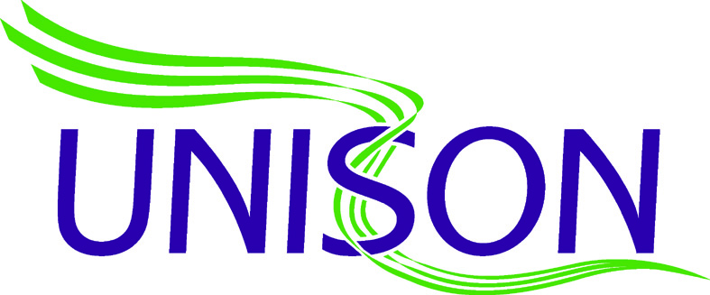

WMAS Newsletter
February 2020 www.wmambo.co.uk

Pay Back of Hours Owed
It has been brought to our attentions that staff are being approached regarding pay back of perceived hours owed.
A grievance has been submitted by all three Unions on 22nd Jan 2020 stating
‘Staff being made to work pay back shifts despite no trust and confidence in hours provided. We believe this to be unlawful’
and a meeting has been arranged for 24th February 2020 to discuss this further.
All staff are entitled to ask for a full written break down and explanation of their hours owed prior to agreeing to any pay back shifts.
If you require Unison representation at any stage during this process , please contact your local Unison representative.

