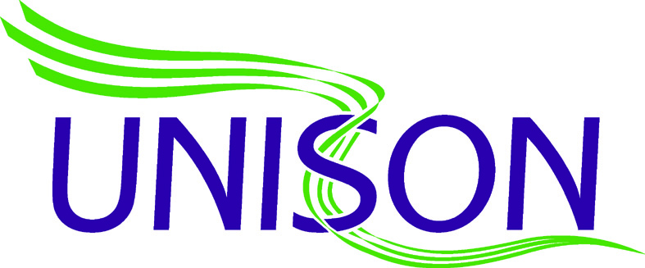
WMAS Newsletter
June 2016

Linked Banding Agreement Ballot Papers

Can any member of staff who is eligible to vote on the Linked Banding Agreement Proposal but has NOT received a Ballot paper please email :
reenafarrington@sky.com as soon as possible with their
Name, Address, Base Station, Rank and Unison Membership Number
Any problems please contact your local rep or use the ‘contact us’ option on the WMAMBO website.
Many Thanks

