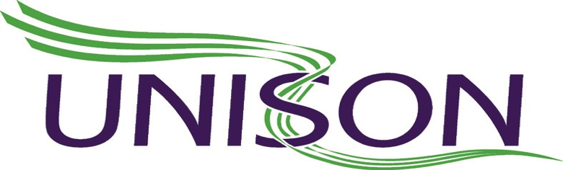

West Midlands Ambulance Service Branch

www.wmambo.co.uk

April 2020

In response to the continued issues raised from our members, WMAS UNISON Branch have been working with our management and colleagues over the last few weeks to secure the following agreed guidance that provides a more appropriate level of PPE for the risks our members encounter. This is after support from Unison nationally pushing these concerns forward to PHE and the government.

We advise our members that, when faced with patient and public contact during the course of their work, that they make a dynamic risk assessment in each contact situation. This should be in the form of an initial assessment, at a safe distance, utilising all the available information including that from EOC / 111 to assess whether the patient has symptoms consistent with Coronavirus.

Due to the nature of the environment and situations that we attend for patients requiring resuscitation, we believe that there is a high risk of aerosol contamination from chest compressions sufficient enough to warrant the available protection of level 3 PPE. We advise that our members use a minimum of level 3 Hoods and Tyvek suit to all patient resuscitations. WMAS Trust has not stipulated this and has confirmed that they will follow all the National guidance however, they have accepted that, as part of the clinician’s initial dynamic risk assessment, should the staff member feel they require level 3 PPE , it is part of their risk assessment to DON that PPE.

Given the Community spread of Coronavirus, PPE needs to be used in line with the PHE guidance. This means, for every patient we have direct contact with, we should wear a surgical face mask, apron, gloves and eye protection (risk assessed) and we were the first in the country to agree this.

After the initial risk assessment, if you believe your patient is at risk of being infected with Covid-19 or symptomatic, we have agreed with the trust you utilise the level of PPE you deem appropriate for your patient. Although there is a limited national and global supply of PPE members should remember that risk assessments are the main factor in determining your level of PPE. Remember if you do not have right PPE do not put yourself at risk

We advise a Tyvek suit can be worn in place of the current poor quality apron as this is the only suitable bodily protection available at this time from the exposure and transmission of infected droplets in a pre-hospital environment, until a time that we have a suitable alternative. We can confirm that a thicker, longer, easier to use and better quality apron has been sought and ordered by the trust (see attachment) after Unison nationally and regionally raised concerns around the flimsy material of the apron, especially in a pre-hospital setting.

Where staff reasonably believe their uniform to have been contaminated during close contact with a patient or person suspected to be infected with Covid-19, they should return to station as soon as safe to do so, decontaminate and replace the contaminated uniform with clean ones

We will continue to gain clarity and challenge the following, however as well as regional guidance a national stance is also sometimes required.

- AGP – Unison is continuing nationally to question and clarify the information currently fed from PHE
- Continued availability of PPE – the branch has successfully argued the personal supply of goggles, face shields for glasses wearers.
- We have asked for a 10% wage increase to those staff now supervising during the Pandemic
- RIDDOR Reporting – (letter attached)
- Utilisation of Fire Service – The Trust has presently advised they have not utilised the fire service therefore will not be utilising them on any frontline vehicle.
- As issues are being raised risk assessments are taking place in conjunction with Unison in true partnership working.

Unison continue to raise concerns around certain areas of staff becoming frontline and the risks associated with this, but they have assisted and supported our members with the amount of pressure in the system and we have also negotiated beneficial terms and conditions for those groups of staff.

EOC

The following safety measure have been agreed by Unison and put place by management within all EOC/111/PTS control centres.

In order to try and maintain social distancing and a clean environment

- Significant increases in antibacterial wipes, hand disinfectant gels and sanitiser dispensers across all control centres
- Perspex screens in between individual desks on dispatch, call taking and clinical positions
- Isolation rooms/offices/areas for those staff with ongoing medical conditions/maternity staff
- Extra call taking and clinical positions installed in other areas with safe 1m distancing
- Temperature testing every shift of all staff
- Alternative/Extra rest room availability
- Introduction of clinical wipe down every hour
- Face masks availability for those who require one

We have also requested for those staff continuing to mentor/supervise staff, that they be seconded into band 4 positions as senior call assessors.

Please contact your local UNISON representative should you have any further questions or issues, details of local representatives can be found on WWW.WMAMBO.CO.UK. Regular updates are given through the HUBS What’s APP groups and local Unison representatives, as the branch finds this quicker and easier to disseminate to members in real time. We will continue to hold weekly national conference calls, which include our devolved countries and we will update you accordingly.

Those who find themselves in financial difficulties can gain advice, support from our Welfare Officer details of which can be found on the above website.

Unisons stance remains the same, your safety is paramount and should be the forefront of any decision you make.

Stay safe

West Midlands Ambulance Branch Committee

